Exp. No. 2
Develop a lexical Analyzer to identify whether a given line is a comment or not using C
AIM: To Develop a lexical Analyzer to identify whether a given line is a comment or not using C
Program:
#include <stdio.h>
#include <string.h>

int main()
{
char com[100]; // Increased buffer size to safely handle inputs
int i = 2, a = 0;

printf("\n Enter comment: ");

// Safely read input to prevent buffer overflow and gets() removal errors
if (fgets(com, sizeof(com), stdin) == NULL) {
return 1;
}

// Remove trailing newline character added by fgets
com[strcspn(com, "\n")] = '\0';

if (com[0] == '/')
{
if (com[1] == '/') {
printf("\n It is a comment\n");
}
else if (com[1] == '*')
{
// Loop safely stops at the end of the text, preventing array out-of-bounds crash
for (i = 2; com[i] != '\0' && com[i+1] != '\0'; i++)
{
if (com[i] == '*' && com[i+1] == '/')
{
printf("\n It is a comment\n");
a = 1;
break;
}
}
if (a == 0) {
printf("\n It is not a comment\n");
}
}
else {
printf("\n It is not a comment\n");
}
}
else {
printf("\n It is not a comment\n");
}

return 0;
}
OUTPUT
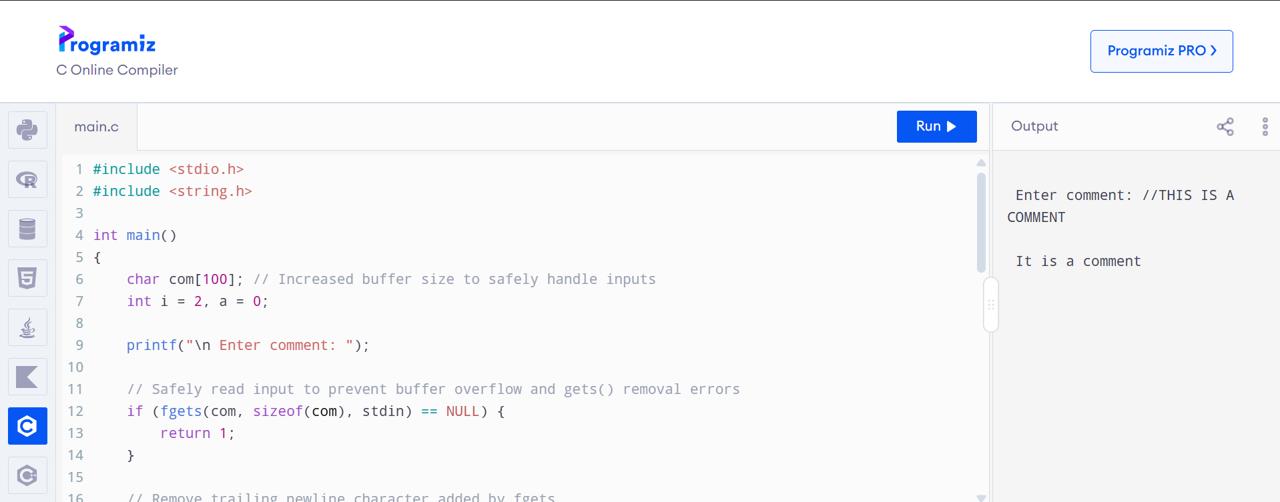
RESULT:Sucessfully Developed a lexical Analyzer to identify whether a given line is a comment or not using C

